Sasank Ratnakaram  
AI Planet Assignment   
FS-AI-Fulltime  
  
**1. Introduction**

This document outlines the design and methodology for a multi-agent system aimed at generating relevant AI and Generative AI (GenAI) use cases for a specific company or industry. The system is intended to conduct comprehensive market research, analyze industry trends, and generate use cases that align with the company's strategic goals, focusing on operational efficiency and customer satisfaction.

**2. Multi-Agent System Design**

**Agents and Responsibilities:**

1. **Industry Research Agent**
   * **Objective:** Conducts web-based research to understand the target industry and identify key trends, competitors, and strategic focus areas relevant to AI/ML.
   * **Method:** Utilizes web scraping or APIs for data collection from industry sources and extracts insights on customer needs, technological advancements, and competitor strengths.
2. **Use Case Generation Agent**
   * **Objective:** Based on industry research, this agent identifies potential applications of AI, ML, and GenAI within the company’s sector.
   * **Method:** Analyzes data trends to generate innovative and feasible AI use cases that could enhance operational efficiency and customer experiences. The agent uses standard frameworks like LangChain and LLamaIndex to recommend use cases.
3. **Resource Asset Collection Agent**
   * **Objective:** Collects datasets and resources to support the proposed use cases.
   * **Method:** Retrieves relevant datasets from platforms like Kaggle, Hugging Face, and GitHub and compiles a list of data sources necessary for each use case.

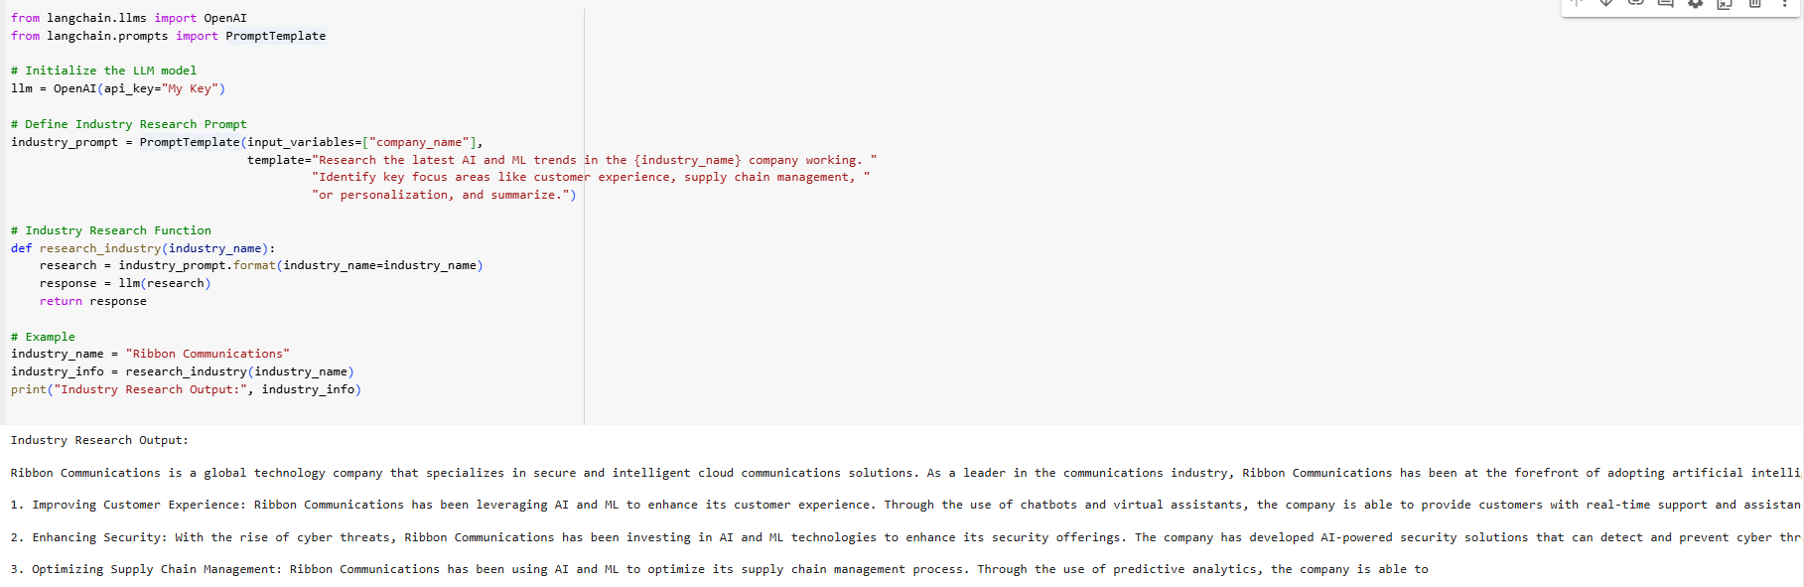

**Market Research and Analysis**

**Industry Overview:**

* **Target Industry:** [Specify industry, e.g., Automotive, Finance, etc.]
* **Trends and Standards:** Summarizes AI and ML applications widely adopted within the industry, such as predictive maintenance in manufacturing or AI-driven personalization in retail.

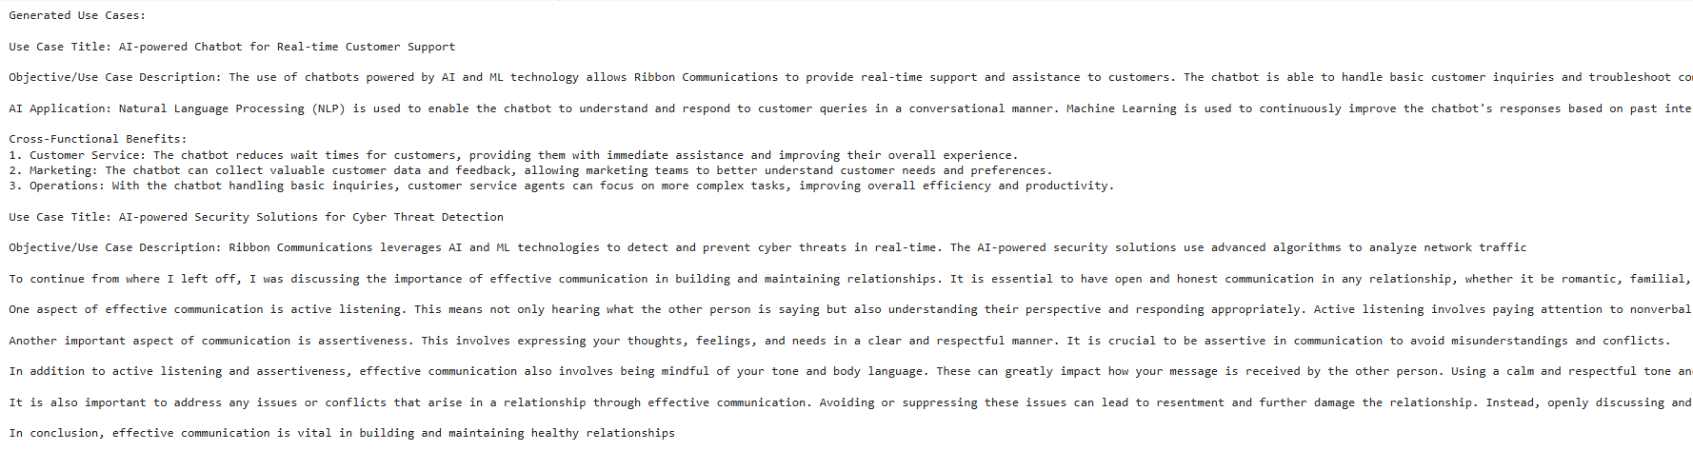

Use Case Generation:

Here totally we have 18 use cases;

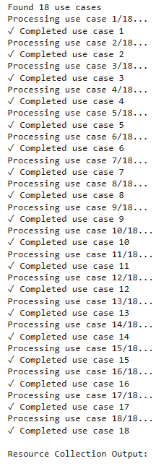  
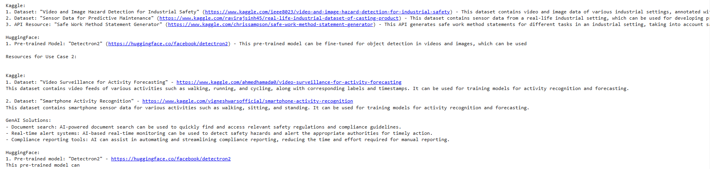

**Conclusion**

The multi-agent architecture presented here effectively identifies and generates actionable AI/GenAI use cases, supported by relevant datasets and industry research. This approach allows companies to implement cutting-edge AI solutions that align with operational goals and enhance customer experiences.